Windfarms and Residential Property Values

Abstract

This study examines the effect that windfarm visibility has on residential property values using a hedonic regression model. The study area is Ashhurst, New Zealand, a township of approximately 900 dwellings. Ashhurst is located within eight kilometres of two separate windfarms that were developed between 1998 and 2007 comprising 103x660kW turbines, 31x3MW turbines, and 55x1.65MW turbines. The analysis uses the 945 open market house sales that occurred in Ashhurst between 1995 and 2008. Visual impact of turbines is studied to capture the impact of windfarms and it is assessed using GIS viewshed analysis and by field inspection. The hedonic models had satisfactory explanatory performance and in each case indicated that the turbines located between 2.5 and 6 kilometres from the township of Ashhurst had no significant impact on property value.

Keywords: Wind turbine, property sale price, viewshed, hedonic regression, GIS.
JEL Classification: R3, D4

1. Introduction
In response to growing pressure for sustainable energy production in New Zealand, seventeen wind farms have been established since the late 1990s and twenty more are proposed. Objection to the development of windfarms is increasing, as concern grows that the visual impact of wind turbines will have a detrimental effect on property values. There is very little empirical evidence on the impact of windfarm development on property values and results are inconclusive.

Sterzinger, et al (2003) conducted the widely cited quantitative study prepared for the Renewable Energy Policy Program (REEP). Statistical analysis was used to compare changes in property values, in the viewshed of several windfarms and in control localities, in the United States. Results were consistent between three different methods of analysis used, and the study concluded that there is no support for the claim that wind development will harm property value. There are limitations with the REPP study, which weaken the results, and the Energy Centre of Wisconsin (2004) attempted to complete a quantitative study improving on the methodology of the REPP Report. However, preliminary analysis indicated that there was insufficient bona fide sales data to provide statistically significant results. Hoen (2006) analyzed 280 bona fide residential property sales using a hedonic regression model and concluded that in the community studied, there was no statistically significant relationship between sale price of residential property and view of, or distance to, the windfarm. Sims and Dent (2007) analysed 1,052 house sales within close proximity of two windfarms in Cornwall, United Kingdom. They found some correlation between distance from a windfarm and value but concluded that other variables, not included in the analysis may be the main drivers of price. Sims et al (2008) used hedonic regression analysis to investigate the impact of a 16 turbine wind farm in Cornwall, on proximate house prices. They analyzed 199 residential sales that had transacted between 2000 and 2007 since the construction of the wind farm. They used geographic information system (GIS) and site visits to gather data on distance to turbines and turbine visibility from the front and rear of the house for each sale. Locational view characteristics (vista) for each sale were also included in the analysis. They found no relationship between the number of wind turbines visible and property value.

Hoen et al. (2011) have conducted the most comprehensive study to date based on almost 7,500 house sales within 16 kilometers of 24 existing wind farms in nine different states in the United States. They developed four different hedonic pricing models to investigate the potential impact on house values of an area stigma, a scenic vista stigma and a nuisance stigma. Extensive field work was undertaken to ensure accurate view variables, with categories assessed for both turbine view and vista not considering the turbines. They concluded that neither view of the turbines nor the distance of the home to the turbine has a significant effect on house sale price.

The other type of impact study that has been conducted has involved surveying local residents, realtors or appraisers to determine how they believe a proposed windfarm development might impact property values. Haughton’s survey of homeowners and realtors in the Cape Cod area, New England, USA was conducted prior to windfarm development (Haughton et al, 2004). Results showed homeowners estimated an average loss in property value of 4% with wind turbines in the landscape. Khatri (2004) surveyed Chartered Surveyors in Great Britain to gauge professional property opinion on the impact of windfarms on property values. This study noted that the number of surveyors who deal with transactions affected by windfarms is low but among those with experience (approximately 80 respondents) their survey suggested that wind farm development reduced property values to some extent, the negative impact starts from the planning stage and appears to decline over time.

Regression analysis is accepted as the most rigorous method of assessing the impact of external factors on property values. It has been widely used to investigate externalities such as 1) the effects of proximity to high voltage electric transmission lines (Colwell, 1990; Hamilton & Schwann, 1995; Des Rosiers, 2002), landfills (Des Rosiers, 2002; Nelson et al, 1992), and airports (Nelson, 2004) and 2) the impact of view (Benson et al, 2000; Bond et al, 2002). The main limitation in applying this method to windfarm impact has been the low volume of sales within the viewshed of established windfarms, as these developments generally occur in rural areas. This study provides the opportunity to investigate the initial impact of windfarm development on residential property value, as developments are located close to a residential area.

2. Study Area
This study is based on the 945 residential houses that sold in Ashhurst between 1995 and 2008. Ashhurst is a 900 household township located 15 kilometres north east of Palmerston North city. Figure 1 shows a map of the locality, from Palmerston North city to the rural township of Ashhurst. All essential services and amenities in Ashhurst, including a primary school, local shops and a community centre, are located on the main road that runs through the centre of the township. The main road services the rural community to the north and traffic flow is light. Ashhurst is of uniform, flat topography, and there are no parts of the township that have obvious beneficial or detrimental locality attributes. Ashhurst has a largely uniform medium cost housing stock. House prices on average over the last ten years have been around 25 percent less than comparable medium cost housing areas in Palmerston North. Ashhurst lies on the river plains at the foot of the Ruahine Ranges close to the gorge that separates the Tararua and Ruahine ranges. These ranges provide an ideal site for windfarm development due to the positive funnelling effect that the Manawatu Gorge has on wind speed, and there are operational windfarms on the ranges on both sides of the Manawatu Gorge. Figure 2 shows the Tararua and Te Apiti windfarm developments in relation to Ashhurst.

The Tararua windfarm was developed between 1998 and 2007; 48 turbines were constructed during 1998, 55 during 2000, and 31 during 2007. It is located on the southern side of the Manawatu Gorge, 4.5 to 6 kilometres from Ashhurst. The Tararua windfarm has a total installed capacity of 161MW and comprises 103 Vestas V47-660kW turbines (tower height of 50 metres and rotor diameter of 47 metres) and 31 Vestas V90 3 MW turbines (tower height of 65 metres and rotor diameter of 90 metres).

The Te Apiti windfarm was developed over 2004 and is located on the northern side of the Manawatu Gorge, 2.5 to 3.5 kilometres from Ashhurst. Te Apiti comprises 55 NEG Micon NM72 1.65MW turbines, a total installed capacity of 90MW. The turbines have a tower height of 70 metres and a rotor diameter of 72 metres.

3. Methodology
The price that a house sells for will depend on its unique combination of physical, location and environmental characteristics. Hedonic regression analysis is a widely used and accepted method of assessing the marginal contribution of individual characteristics to value and generally takes the form;
Price = ƒ (Physical characteristics, other factors)

Sirmans et al (2005) reviewed recent studies that used hedonic modelling to estimate house prices and identified the variables that were consistently used in explaining price. The significant variables identified by Sirmans included; land area, house structure (size, construction, age), interior features (bedrooms, bathrooms, heating), external amenities (garaging, decking), environmental factors (views, location, schools). These variables were considered in relation to the New Zealand housing market in general and the Ashhurst market specifically, in order to include the most relevant variables in this study. Data on land area and house structure was available and was included in the model. Data on interior features and external amenities was not available. Environmental factors were considered in relation to the study area and turbine visibility was assessed as the only important environmental factor necessary in this model. Ashhurst fits the McCluskey and Borst (2007) description of a neighbourhood as a smaller area within a market segment where market influences are relatively constant. Figure 1 shows the location of the township in relation to the most commonly used locational attributes identified by Kryvobokov (2007) of access to a commercial centre (Palmerston North city), water (the Manawatu River) and green areas (Ashhurst Domain). The small and compact nature of Ashhurst means that there is very little difference in travel distance to any of these key locational attributes. The turbines and the ranges that they are built on dominate the view from Ashhurst houses and there are no other unique scenic vistas in this locality. Distance to the turbines was considered and was not included as a variable in the model as all houses are sited within 2.5 to 3.5 kilometres of the closest turbine, this distance falls within the third distance zone used by Hoen et al. (2011).

3.1. Data and Variables
Sales data was sourced from Headway Systems Ltd ValBizTM sales database. Sales of residential houses in Ashhurst from 1 January 1995 to November 2008 were extracted from the ValBizTM database. Residential sales data for the Palmerston North suburb of Milson was also extracted for use as a control neighbourhood. Erroneous data was identified and removed including; non-market sales, duplicate sales, transactions with a sale price less than $10,000 and properties with land area greater than one hectare. This produced a database of 945 Ashhurst and 568 Milson sales. Sale details, house construction and location information was also extracted for each sale. To further develop the database it was necessary to add variables relating to the turbines.

3.2. Turbine Visibility and Viewshed Analysis
Correct definition of the viewshed is critical to the study. Both Sterzinger et al (2003) and Hoen (2006) have used a radius of 8 kilometres (5miles) from the windfarm as the outer limit of the viewshed. Sterzinger’s reason for using this distance is based on review of studies of line of sight and interviews with industry experts. This 8 kilometre radius is adopted as an accepted standard in this study. Turbine visibility and distance to turbines were considered. The township is compact (approximate width of one kilometre) and lies below the Te Apiti turbines some 2.5 kilometres from the closest turbine. The closest Tararua turbines are approximately 4.5 kilometres from the southern end of Ashhurst. The differences in distance of the two windfarms from Ashhurst provide a means of identifying the impact of distance on property value.

The visibility of turbines within the 8 kilometre radius is of importance and was initially calculated using GIS (Hoen used a similar method in his 2006 study). Twenty metre digital elevation model (DEM) data was used. Ground cover was not factored into the viewshed model. Most houses in Ashhurst have well established gardens; outside the township the landscape is mostly pastoral. Ashhurst is at an elevation of 80 metres above sea level and ground elevations of the turbines range from 239 to 523 meters for the Tararua windfarm and from 240 to 410 metres for the Te Apiti windfarm.

Viewsheds were calculated using Idrisi Andes VIEWSHED analysis to determine the number of turbines visible from each sale property. Separate viewsheds were calculated for each set of turbines, this was done to take into account the varying heights of the different sets of turbine towers. The individual viewsheds were combined to create four stages of windfarm development (Stage 1- 48 Tararua turbines, Stage 2 – 103 Tararua turbines, Stage 3 – 103 Tararua turbines plus 55 Te Apiti turbines, Stage 4 – 134 Tararua turbines plus 55 Te Apiti turbines). Visibility was defined as a clear line of sight from each point within the viewshed to the top of each turbine tower with 100 percent visibility being clear line of sight to the top of all turbine towers constructed at any stage.

Figure 2 shows viewshed proportion, within an 8 kilometre radius of the Tararua and Te Apiti windfarms, at Stage 3 of the windfarm development and Figure 3 shows the viewshed proportion, at Stage 4 of the windfarm development, for houses sold in Ashhurst over the study period. Table 1 shows results of the GIS viewshed analysis; the figures indicate the maximum and minimum percentages and numbers of turbines visible from Ashhurst on completion of the first three stages of windfarm development.

Visibility of the turbines was also investigated by field inspection to assess accuracy of viewshed results. The numbers of turbines predicted to be visible were confirmed as visible on field inspection only when trees and other buildings did not obstruct the view. To ensure accuracy of the turbine visibility data used in the hedonic analysis all houses in the Ashhurst dataset were inspected and the number of Te Apiti turbines visible from the front of each property counted. A turbine was defined as visible when the top of the tower could be seen.

3.3. Variable Definitions
The basic model is represented as:
Price = ƒ (year of sale, time of year, land area, floor area, age of dwelling, exterior cladding, visible turbines)
Where;
Price (natural log form of nominal total sale price, NZ$) - Various adjustments were trialled to determine the appropriate form for the dependant variable. Sale price was adjusted to June 1995 dollars by the Quotable Value Price Index for Palmerston North residential and also by the consumer price index. These adjustments were found to be inappropriate so dummy variables were constructed to represent year of sale (Sims et al., 2008).
Land Area - The total land area expressed in square metres.
Floor Area and floor area squared - The total floor area of the house expressed in square metres, rounded to the nearest ten square metres (as listed in the ValBizTM database). Floor area squared was also generated.
Exterior Cladding - The houses were grouped into five categories; Brick, fibrolite, roughcast, weatherboard, mixed and other.
Age of Dwelling and age squared - The ValBizTM sales database provides the decade in which the house was constructed. This was converted to age of dwelling to the nearest 10 years. Age squared was also generated.
Year of Sale - The year in which the sale occurred.
Time of Year – The quarter in which the sale occurred and a dummy variable for a summer sale.
Wind Turbine Related Variable - Four alternative variables were tested
1. Turbine Visibility: Binary sample of visibility at time of sale (visible/not visible) derived from field inspection
2. Te Apiti (GIS): Number of Te Apiti turbines predicted as visible by GIS
3. Te Apiti count: Number of Te Apiti turbines counted as visible on field inspection
4. Tararua (GIS): Number of Tararua turbines predicted as visible by GIS

In Table 2, we report the descriptive statistics for two different samples we have used in our estimations. Approximately 34% and 36% of the houses sold have the visibility to turbines in both Ashhurst (1995-2008) and merged Ashhurst and Milson (2005-2008) samples respectively. Table 3 prints the correlations of all variables for two different sub-samples included in the regression analysis. We didn’t observe high correlations among the variables included in each regression.

4. RESULTS AND DISCUSSION
Sales data was analysed using ordinary least squares technique. Regression results for various models developed covering two different time periods and using four different forms of turbine visibility variable to get robust estimates are summarised in Table 4.

In Table 4 column (1) to (4), we report the estimation results for the first analysis covering the Ashhurst market after construction of the Te Apiti wind farm in 2005. This time period (2005 to 2008) provided a dataset of 315 sales. The natural log of sale price was used as the dependant variable and all dwelling variables, time and quarter dummies for seasonality, a dummy for summer sales, and a turbine variable were included as independent variables. Four forms of turbine visibility were tested; firstly a dummy for Te Apiti turbine visibility derived from field inspection, secondly the number of Te Apiti turbines predicted as visible by GIS modelling, thirdly the number of Te Apiti turbines recorded as visible on field inspection and finally the number of Tararua turbines predicted as visible by GIS modelling. The time dummy variables for 2006 to 2008 are positively significant compared to sales completed in 2005 and show the expected yearly inflation of house prices and the market correction in 2008. Floor area and land area are both positively significant and age is negatively significant at 0.01 level. The number of turbines visible from the property is positive with the dummy and field count variables and negative with the GIS generated variables but they are all insignificant in predicting house sale price in any form.

In Table 4 column (5) to (8), we report the estimation results for the second model covering the Ashhurst market from 1995, nine years prior to the development of the Te Apiti wind farm and three years prior to development of the first stage of the Tararua wind farm, until 2008. We specifically chose this period to investigate the possible impact of area stigma since announcement of construction of the wind farms. This time period provided a dataset of 945 sales. As in the first analysis, the natural log of sale price was used as the dependant variable and all dwelling variables, time and quarter dummies for seasonality, a dummy for summer sales, and a turbine visibility variable were included as independent variables. The four forms of turbine visibility were tested. The time dummy variables from 2003 to 2008 are positively significant compared to sales completed in 1995 and show the expected yearly inflation of house prices and the market correction in 2008. Floor area and land area are both positively significant and age is negatively significant at 0.01 level. The Te Apiti turbine visibility variables are all positive and only Te Apiti from GIS variable is significant at 0.10 level. However the Tararua turbine visibility variable has a significant negative impact on sale prices at 0.10 level.

In Table 4 column (9) to (11), we report the estimation results for the third model covering the time period from 2005 to 2008, after construction of the Te Apiti wind farm, and included the Palmerston North suburb of Milson as a control locality, a dataset of 883 sales. The natural log of sale price was used as the dependant variable and an Ashhurst dummy variable, all dwelling variables, time and quarter dummies for seasonality, a dummy for summer sales, and a turbine variable were included as independent variables. As the visible turbine dummy variable is perfectly correlated with the Ashhurst dummy variable, it was not used in this analysis. The other three forms of turbine visibility were tested. The Ashhurst dummy variable is negative showing the expected difference in house prices between Ashhurst and Milson. The time dummy variables from 2006 to 2008 are positively significant compared to sales completed in 2005 and show the expected yearly inflation of house prices and the market correction in 2008. Floor area and land area are both positively significant and age is negatively significant at 0.01 level as expected. The number of turbines visible from the property is positive with the Te Apiti field count variable and negative with the GIS generated variables but is not significant in predicting house sale price in any form.

The developed hedonic pricing models have reasonable explanatory performance with an R² of greater than 61%. The models indicate that the presence of the Te Apiti turbines (turbines with a maximum tower height of 70 metres and a rotor diameter of 72 metres) have not had a significant impact on sale price of a residential property that is within 3.5 kilometres but further than 2.5 kilometres from the nearest turbine and that the presence of the Tararua turbines (turbines with a tower height of 50 metres and a rotor diameter of 47 metres) have not had a significant impact on sale price of a residential property that is within 4.5 to 6 kilometres of the nearest turbine.

For sensitivity analysis we also investigated the influence of repeated sales on current house price. We created categorical dummies for repeated sales and rerun the hedonic regressions controlling for them. Specifically we defined three categories for repeated sale; sold once, sold twice, sold more than twice within the sample period. The coefficients of these dummies were all insignificant at 0.10 level, they had no impact on the coefficients and the significance of the rest of the variables and adjusted R-square was exactly same (to two decimal places). To keep the simple form of hedonic regressions, we only report the regression results without these dummies.

5. Conclusions
Construction of hedonic pricing models is an accepted method of investigating the impact of windfarm development on sale price of residential property. The township of Ashhurst, New Zealand provides a suitable study area with sufficient bona fide residential sales data to provide statistically significant results. GIS viewshed analysis using 20m DEM data was only useful as a preliminary guide to turbine visibility. Field inspection is necessary to record accurate impact of turbine visibility on each individual property.

The regression models developed in this study had satisfactory explanatory performance with R² of 61% to 82%. The results indicate that the Tararua and Te Apiti turbines had no significant impact on sale price of Ashhurst residential property. The results of this study are specific to the study area and care should be taken when transferring these findings to other situations. The results provide an initial estimate of the impact of windfarm development on house prices. Further development of the hedonic models, such as GWR (Geographically Weighted Regression) is recommended. Consideration should also be given to the view variables employed in this study. Turbine visibility from the road front was used but no account was taken of the orientation to the wind farm (Sims et al., 2008).

From a policy perspective the findings are consistent with other studies (Hoen 2006; Hoen et. al 2011; Sims et. al 2008) and suggest that in localities similar to Ashhurst the construction of wind turbines is unlikely to have a detrimental impact on residential property values.

References

Benson, E.D., Hansen, J.L., and Schwartz Jnr, A.L. (2000). Water Views and Residential Property Values. The Appraisal Journal, pp. 260-271.

Bond, M.T., Seiler, V.L., and Seiler, M.J. (2002). Residential Real Estate Prices: A Room with a View. Journal of Real Estate Research, 23, pp. 129-138.

Colwell, P.F. (1990). Power Lines and Land Value. Journal of Real Estate Research. 5(1), pp. 117-128.

Des Rosiers, F. (2002). Power Lines, Visual Encumbrances and House Values: A Micro Spatial Approach to Impact Measurement. Journal of Real Estate Research, 23(3), pp. 275-301.

Energy Centre of Wisconsin (2004). A Study of Wind Energy Development in Wisconsin. A Report prepared for State of Wisconsin, Department of Administration, Division of Energy. Retrieved 8 August 2006 from the World Wide Web. http://72.36.212.11/prod/231-1.pdf

Hamilton, S.W. and Schwann, G.M. (1995). Do High Voltage Lines Affect Property Value? Land Economics, 71(4), pp. 436-444.

Haughton, J., Giuffre, D., Barrett, J. and Tuerck, D.G. (2004). Free But Costly: An Economic Analysis of a Wind Farm in Nantucket Sound. Beacon Hill Institute at Suffolk University, Boston MA. Retrieved 8 August 2006 from the World Wide Web. http://www.beaconhill.org/BHIStudies/Windmills2004/CapeWindEconAnalysis31604.pdf

Hoen, B. (2006). Impact of Windmill Visibility on Property Values in Madison County, New York. Unpublished Project Report Submitted to the Faculty of the Bard Centre for Environmental Policy. Bard College, Annandale on Hudson, New York.

Hoen, B., Wiser, R., Cappers, P., Thayer, M., and Sethi, G. (2011). Wind Energy Facilities and Residential Properties: The Effect of Proximity and View on Sales Prices. Journal of Real Estate Research. Vol.33 No.3 pp. 279-316.

Khatri, M. (2004). RICS Wind Farm Research: Impact of Wind Farms on the Value of Residential Property and Agricultural Land. Royal Institute of Chartered Surveyors. Retrieved 8 August 2006 from the World Wide Web.
http://www.rics.org/Property/Residentialproperty/Residentialpropertymarket/wind+farms+hit+house+prices.htm

Kryvobokov, M. (2007). What location attributes are the most important for market value? Extraction of attributes from regression models, Property Management, Vol. 25, No 3, pp. 257-286.

McCluskey, W. J. and Borst, R. A. (2007), Specifying the effect of location in multivariate valuation models for residential properties: A critical evaluation from the mass appraisal perspective, Property Management, Vol. 25, No 4, pp. 312 – 343.

Nelson, A.C., Genereux, J. and Genereux, M. (1992). Price effects of Landfills on House Values. Land Economics, 68(4), pp. 359-365.

Nelson, J.P. (2004). Meta-Analysis of Airport Noise and Hedonic Property Values: Problems and Prospects. Journal of Transport Economics and Policy. 38(1), pp. 1-28.

Sims, S. and Dent, P. (2007). Property stigma: wind farms are just the latest fashion, Journal of Property Investment and Finance, Vol. 25, No 6, pp. 626-651.

Sims, S., Dent, P. ,and Oskrochi, G.R. (2008) Modeling the Impact of Wind Farms on House Prices in the UK. International Journal of Strategic Property Management. 12(4), pp. 251-269.

Sirmans, G.S., Macpherson, D.A., and Zietz, E.N.l (2005). The Composition of Hedonic Pricing Models. Journal of Real Estate Literature, 13(1), pp. 3-42.

Sterzinger, G., Beck, F. and Kostiuk, D. (2003). The Effect of Wind Development on Property Values, Renewable Energy Policy Project. Prepared for the Renewable Energy Policy Program, Washington D.C., USA. Retrieved 14 July 2006 from the World Wide Web. http://www.repp.org/articles/static/1/binaries/wind_online_final.pdf

Figure 1 Map of study area
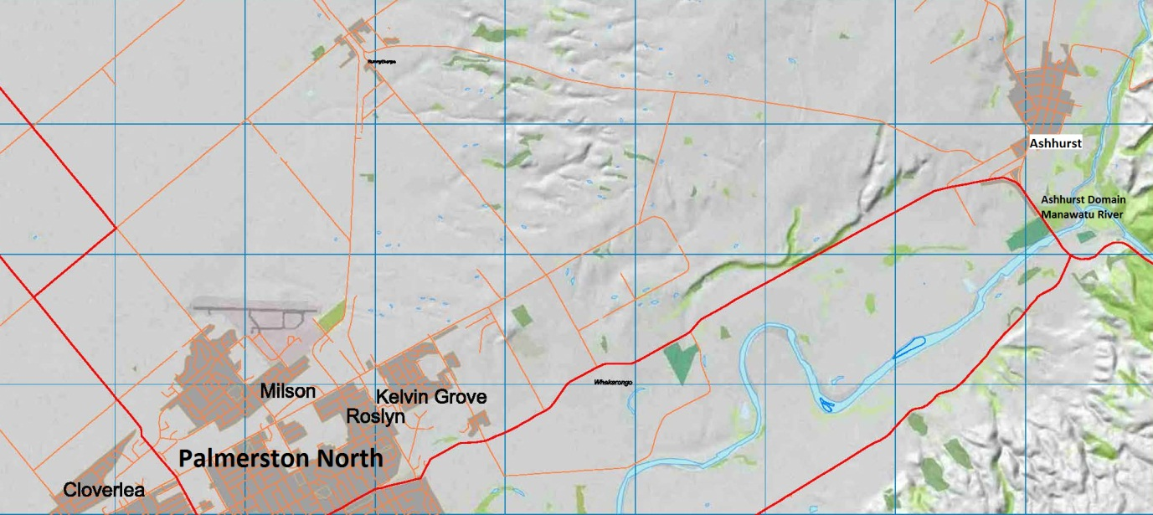
Approximate scale: 1:100,000

Figure 2 Tararua and Te Apiti windfarm developments and viewshed proportion

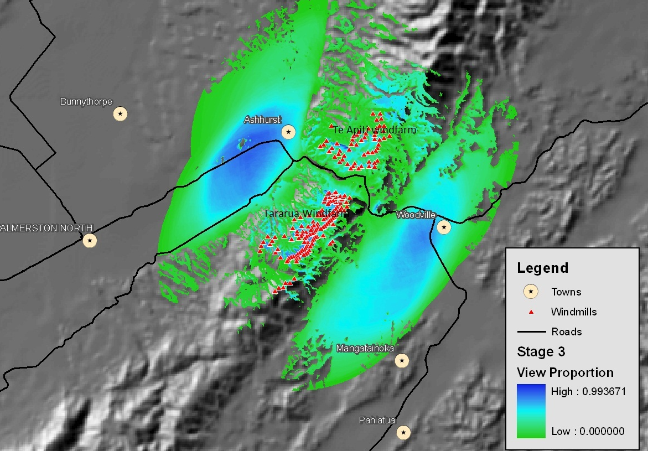
Approximate scale: 1:250,000
Figure 3 Ashhurst house sales within the viewshed
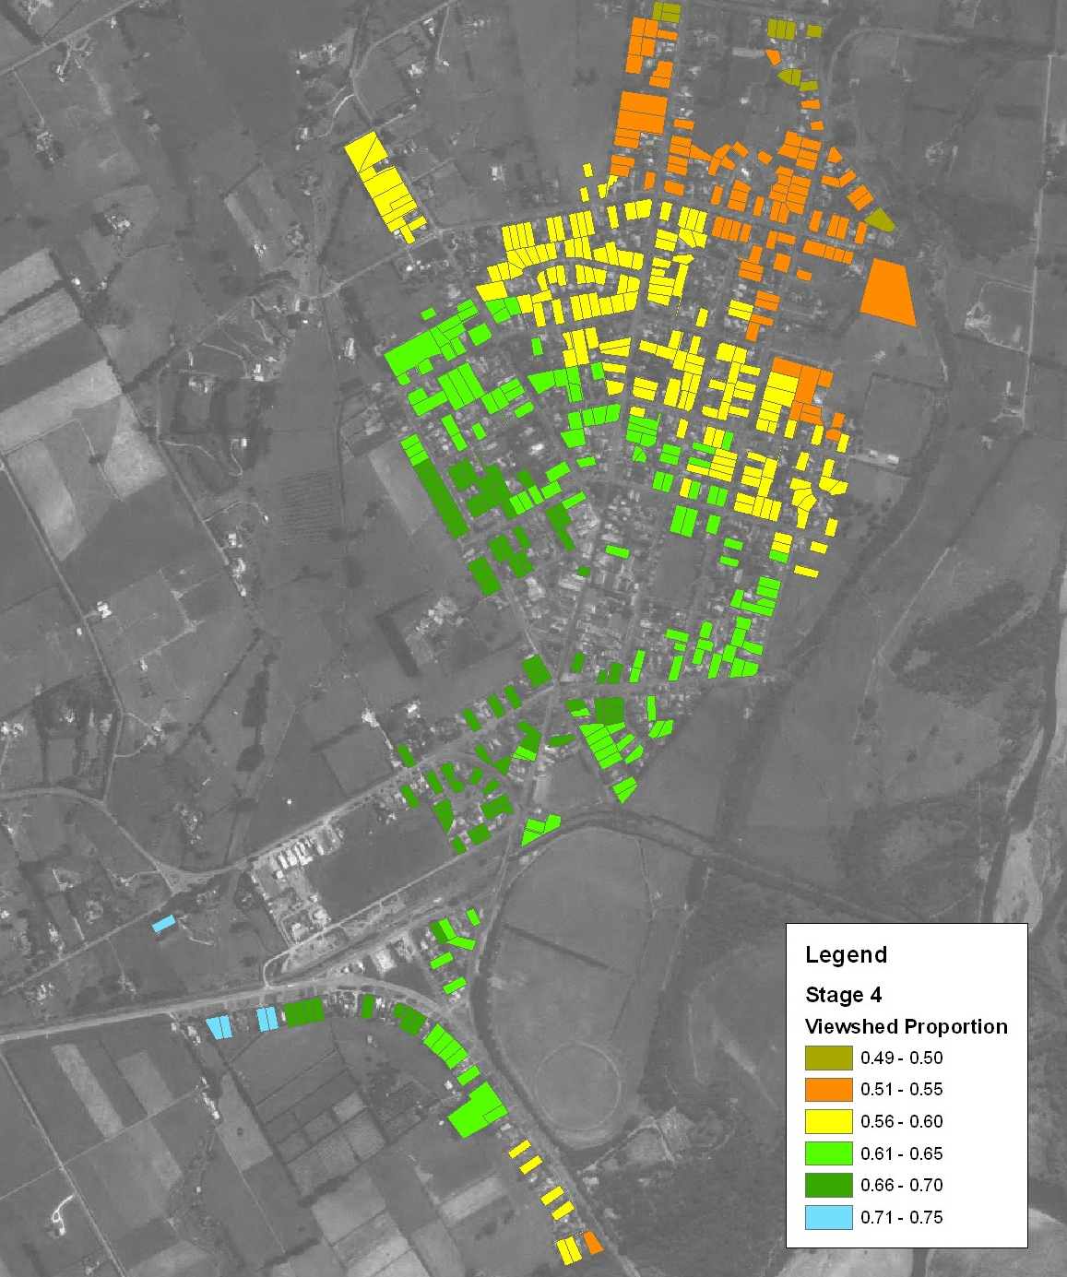
Approximate scale: 1:16,000

Table 1 Turbine visibility from Ashhurst

Stage of windfarm development | Percentage visible turbines | Number of turbines visible
Stage 1 | 44-95% | 21 to 45 50m turbines
Stage 2 | 60-90% | 62 to 92 50m turbines
Stage 3 | 51-80% | 62 to 92 50m turbines and  18 to 34 70m turbines

Table 2 Descriptive Statistics

 | Ashhurst: 1995-2008 |  |  |  |  |  | Ashhurst and Milson : 2005-2008
Variable | Obs | Mean | Std. Dev. | Min | Max |  | Obs | Mean | Std. Dev. | Min | Max
Turbine Visibility | 945.00 | 0.34 | 0.47 | 0.00 | 1.00 |  | 883.00 | 0.36 | 0.48 | 0.00 | 1.00
Te Apiti (GIS) | 945.00 | 8.69 | 10.87 | 0.00 | 31.00 |  | 883.00 | 8.09 | 10.98 | 0.00 | 31.00
Te Apiti count | 945.00 | 3.77 | 6.19 | 0.00 | 25.00 |  | 883.00 | 3.46 | 6.16 | 0.00 | 25.00
Tararua (GIS) | 736.00 | 73.15 | 5.60 | 62.00 | 92.00 |  | 674.00 | 11.59 | 26.94 | 0.00 | 87.00
Age | 945.00 | 35.40 | 21.19 | 1.00 | 90.00 |  | 883.00 | 35.91 | 20.54 | 0.00 | 95.00
Land | 945.00 | 998.92 | 529.50 | 298.00 | 6980.00 |  | 883.00 | 803.42 | 284.57 | 298.00 | 4047.00
Floor Area | 945.00 | 129.93 | 47.81 | 40.00 | 420.00 |  | 883.00 | 141.74 | 53.42 | 40.00 | 420.00
Brick | 945.00 | 0.15 | 0.36 | 0.00 | 1.00 |  | 883.00 | 0.19 | 0.39 | 0.00 | 1.00
Fibrolite | 945.00 | 0.29 | 0.45 | 0.00 | 1.00 |  | 883.00 | 0.25 | 0.43 | 0.00 | 1.00
Roughcast | 945.00 | 0.10 | 0.29 | 0.00 | 1.00 |  | 883.00 | 0.16 | 0.36 | 0.00 | 1.00
Weatherboard | 945.00 | 0.36 | 0.48 | 0.00 | 1.00 |  | 883.00 | 0.32 | 0.47 | 0.00 | 1.00
Quarter 1 | 945.00 | 0.29 | 0.46 | 0.00 | 1.00 |  | 883.00 | 0.29 | 0.45 | 0.00 | 1.00
Quarter 2 | 945.00 | 0.23 | 0.42 | 0.00 | 1.00 |  | 883.00 | 0.23 | 0.42 | 0.00 | 1.00
Quarter 3 | 945.00 | 0.02 | 0.14 | 0.00 | 1.00 |  | 883.00 | 0.25 | 0.43 | 0.00 | 1.00
Summer | 945.00 | 0.29 | 0.45 | 0.00 | 1.00 |  | 883.00 | 0.27 | 0.44 | 0.00 | 1.00
Ashhurst | . | . | . | . | . |  | 883.00 | 0.36 | 0.48 | 0.00 | 1.00

Notes: Ashhurst is dummy variable to denote the sale belongs to Ashhurst area. Quarter dummies denote the time of sale in that year. For example, Quarter 1 dummy takes the value of 1 if a sale occurred in the first quarter of that year.

Table 3 Correlations for different sub-samples
Panel A: Ashhurst data for the period 1995 to 2008
 | Turbine  Visibility | Te Apiti | Te Apiti  Count | Tararua | Age | Land | Floor  Area | Brick | Fibrolite | Roughcast | Weatherboard
Turbine Visibility | 1.00
Te Apiti (GIS) | 0.80 | 1.00
Te Apiti Count | 0.86 | 0.71 | 1.00
Tararua (GIS) | 0.01 | 0.10 | 0.03 | 1.00
Age | 0.00 | -0.02 | 0.03 | 0.19 | 1.00
Land | -0.05 | -0.06 | -0.05 | 0.02 | 0.39 | 1.00
Floor Area | -0.02 | -0.04 | -0.03 | -0.07 | 0.04 | 0.30 | 1.00
Brick | 0.01 | -0.04 | 0.02 | -0.09 | -0.17 | -0.03 | 0.26 | 1.00
Fibrolite | -0.04 | 0.01 | -0.03 | -0.17 | -0.39 | -0.19 | -0.27 | -0.27 | 1.00
Roughcast | 0.00 | 0.01 | 0.00 | 0.10 | 0.03 | -0.05 | 0.04 | -0.14 | -0.20 | 1.00
Weatherboard | 0.04 | 0.02 | 0.04 | 0.12 | 0.48 | 0.23 | -0.03 | -0.32 | -0.47 | -0.24 | 1.00

Panel B: For merged Ashhurst and Milson data for the period 2005 to 2008
 | Turbine  Visibility | TeApiti | Te Apiti  Count | Tararua | Age | Land | Floor  Area | Brick | Fibrolite | Roughcast | Weatherboard | Ashhurst
TurbineVisibility | 1.00
TeApiti (GIS) | 0.99 | 1.00
Te Apiti Count | 0.78 | 0.76 | 1.00
Tararua (GIS) | 1.00 | 1.00 | 0.78 | 1.00
Age | 0.08 | 0.08 | 0.09 | 0.08 | 1.00
Land | 0.36 | 0.37 | 0.26 | 0.37 | 0.26 | 1.00
Floor Area | -0.16 | -0.16 | -0.13 | -0.16 | -0.52 | 0.05 | 1.00
Brick | -0.07 | -0.09 | -0.01 | -0.08 | -0.29 | -0.02 | 0.36 | 1.00
Fibrolite | 0.10 | 0.10 | 0.02 | 0.10 | -0.07 | -0.08 | -0.26 | -0.28 | 1.00
Roughcast | -0.08 | -0.07 | -0.06 | -0.07 | -0.15 | -0.02 | 0.28 | -0.23 | -0.25 | 1.00
Weatherboard | 0.03 | 0.04 | 0.04 | 0.03 | 0.45 | 0.06 | -0.35 | -0.33 | -0.36 | -0.30 | 1.00
Ashhurst | 1.00 | 0.99 | 0.78 | 1.00 | 0.08 | 0.36 | -0.16 | -0.07 | 0.10 | -0.08 | 0.03 | 1.00

Table 4: Hedonic Regression Estimates
Dependent Variable: The Logarithmic form of the nominal total sale price of each house sold
 | Ashhurst/ 2005-2008 |  |  |  | Ashhurst/1995-2008 |  |  |  | Ashhurst & Milson/2005-2008
Explanatory Variables | (1) | (2) | (3) | (4) | (5) | (6) | (7) | (8) | (9) | (10) | (11)
Turbine Visibility | 0.008 | - | - | - | 0.006 | - | - | - | - | - | -
 | (0.03) |  |  |  | (0.22)
Te Apiti (GIS) | - | -0.005 | - |  | - | 0.006 | - | - | -0.004 | - | -
 |  | (-1.31) |  | - |  | (1.69) |  |  | (-0.92)
Te Apiti Count | - | - | 0.007 | - | - | - | 0.001 | - | - | 0.001 | -
 |  |  | (0.57) |  |  |  | (0.97) |  |  | (0.95)
Tararua (GIS) | - | - | - | -0.003 | - | - | - | -0.002 | - | - | -0.003
 |  |  |  | (-0.84) |  |  |  | (-1.75) |  |  | (-1.15)
Ashhurst | - | - | - | - | - | - | - | - | -0.11 | -0.205 | -0.011
 |  |  |  |  |  |  |  |  | (-1.22) | (-11.36) | (-0.06)
Age | -0.692 | -0.667 | -0.692 | -0.756 | -0.662 | -0.701 | -0.663 | -0.704 | -0.857 | -0.861 | -0.94
 | (-5.87) | (-5.49) | (-5.89) | (-3.10) | (-5.08) | (-5.13) | (-5.19) | (-3.81) | (-9.55) | (-9.64) | (-8.43)
Age² | 0.004 | 0.004 | 0.004 | 0.005 | 0.003 | 0.003 | 0.003 | 0.003 | 0.005 | 0.005 | 0.006
 | (2.79) | (2.55) | (2.78) | (1.88) | (2.01) | (2.20) | (2.03) | (1.58) | (4.85) | (4.87) | -(4.19)
Floor Area | 0.647 | 0.655 | 0.646 | 0.458 | 0.842 | 0.84 | 0.841 | 0.88 | 0.548 | 0.542 | 0.459
 | (6.88) | (7.08) | (6.88) | (3.84) | (13.22) | (12.58) | (13.11) | (11.99) | (9.53) | (9.62) | (7.60)
Floor Area² | -0.001 | -0.001 | -0.001 | -0.000 | -0.001 | -0.001 | -0.001 | -0.001 | -0.000 | -0.000 | -0.000
 | (-3.89) | (-4.11) | (-3.88) | (-2.04) | (-8.20) | (-7.70) | (-8.11) | (-7.43) | (-4.65) | (-4.62) | (-3.10)
Land | 0.017 | 0.017 | 0.017 | 0.01 | 0.012 | 0.012 | 0.012 | 0.011 | 0.018 | 0.018 | 0.016
 | (6.79) | (6.76) | (6.76) | (1.59) | (6.49) | (6.50) | (6.53) | (5.45) | (8.20) | (8.25) | (5.14)
Sample Size | 315 | 315 | 315 | 106 | 945 | 945 | 945 | 736 | 883 | 883 | 674
R-square | 0.80 | 0.71 | 0.71 | 0.61 | 0.81 | 0.81 | 0.81 | 0.70 | 0.78 | 0.78 | 0.82
Notes: The coefficients of age, age2, floor area, floor area2, and land are multiplied by 100. All regressions include a constant, year dummies, quarter dummies for seasonality, a dummy for summer, dummies for exterior cladding but their coefficients are not reported. t-statistics are in parentheses.

Reduced sample size for columns 4, 8 and 11 as data on Tararua turbine visibility was only available for sales between 1995 and 2006

